Given an integer array nums where the elements are sorted in **ascending order**, convert *it to a*

***height-balanced***

*binary search tree*.

**Example 1:**

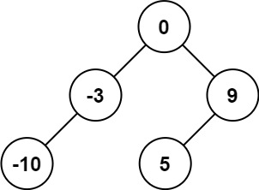

Input: nums = [-10,-3,0,5,9]  
Output: [0,-3,9,-10,null,5]  
Explanation: [0,-10,5,null,-3,null,9] is also accepted:

**Example 2:**

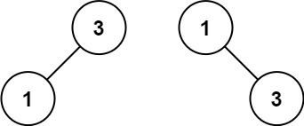

Input: nums = [1,3]  
Output: [3,1]  
Explanation: [1,null,3] and [3,1] are both height-balanced BSTs.

**Constraints:**

* 1 <= nums.length <= 104
* -104 <= nums[i] <= 104
* nums is sorted in a **strictly increasing** order.